Mic → Bias + Coupling → MCP6024 preamp → MCP6024 MFB band-pass @ 2.8 kHz → Envelope detector → Comparator
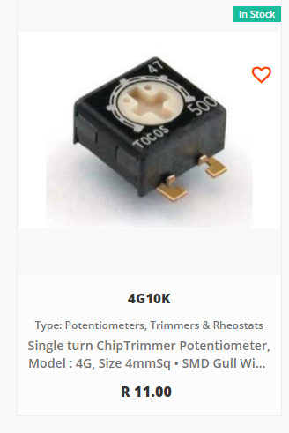
4G 10k (2 of them)
4G 20k (2 of them)
4G 100k ( 2 of them)
4G 500k ( 2 of them)
4G 1M ( 3 of them)
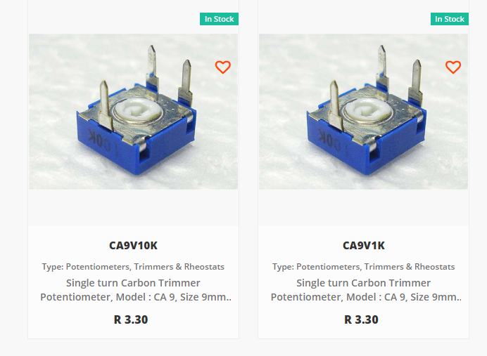
10k (4 of them)
1k ( 3 of them)
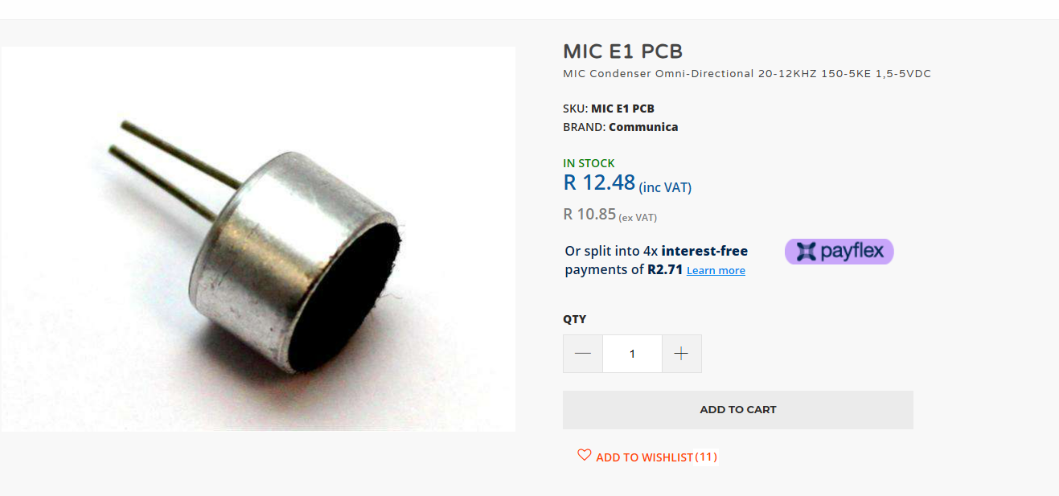
MIC E1 PCB - 3 of them
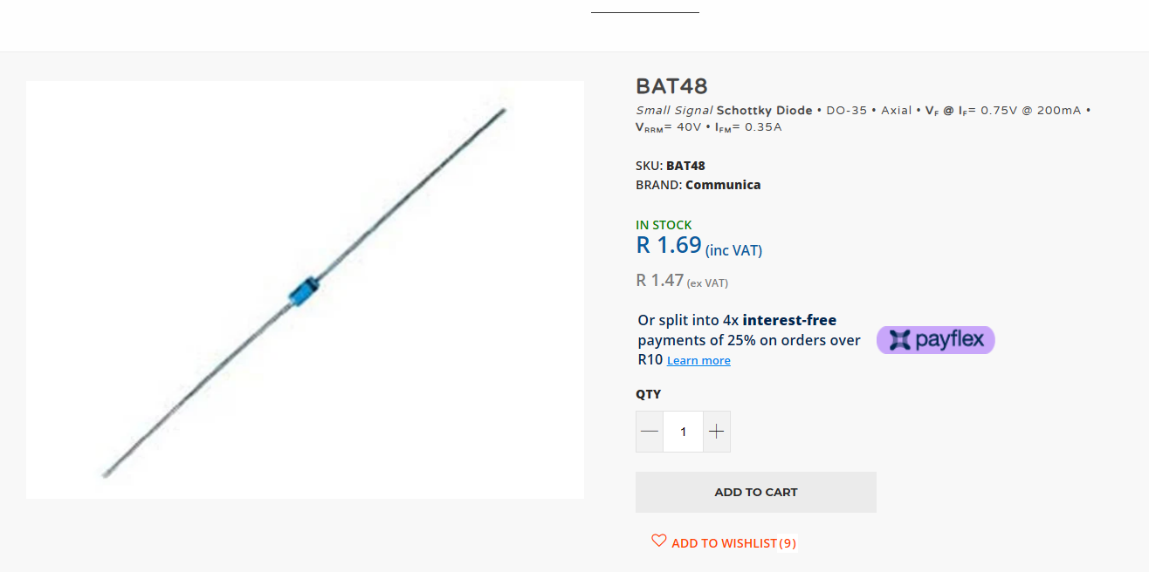
BAT48 - 4 of them

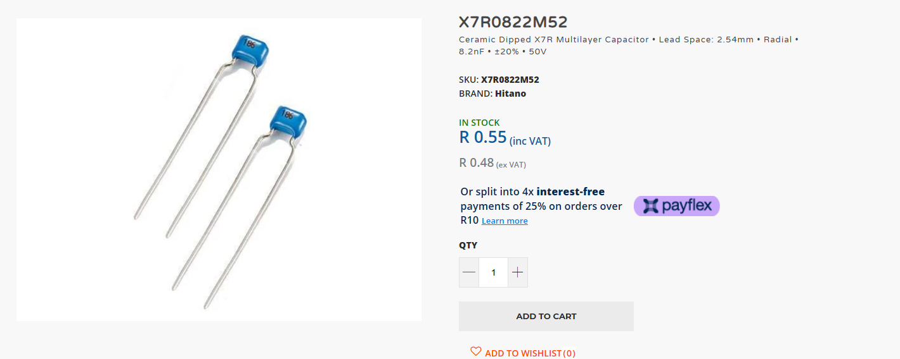
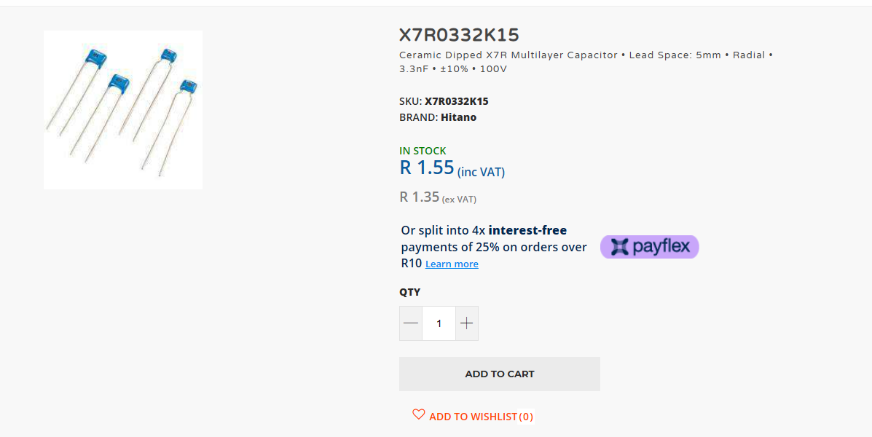
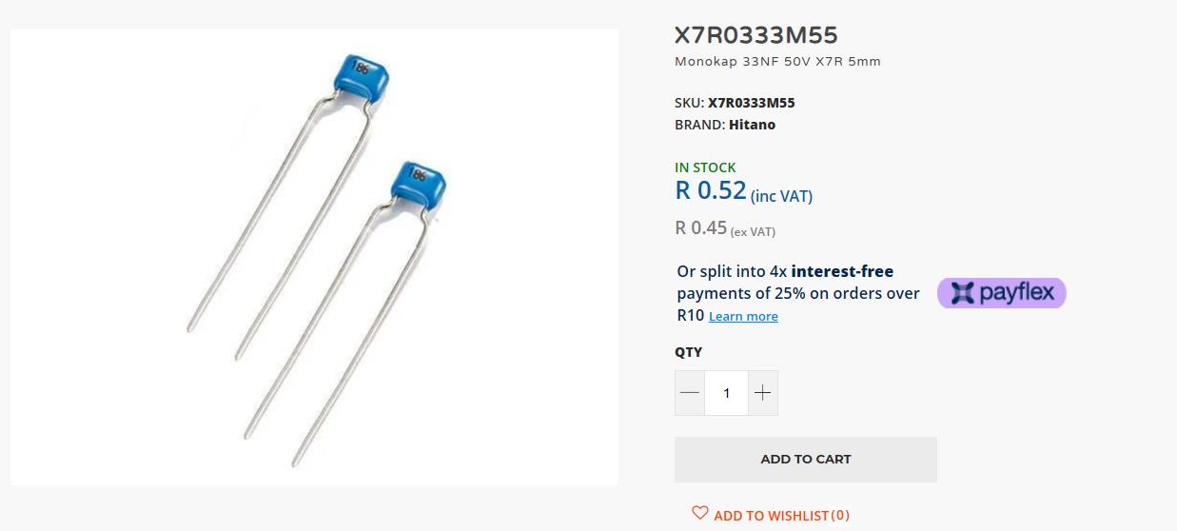
At minum:
33n – 10 of them
3.3 – 5 of them
8.2n – 5 of them

